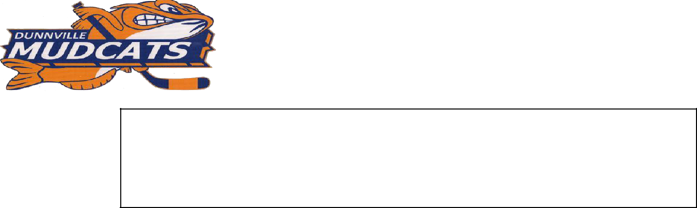

DUNNVILLE MINOR HOCKEY ASSOCIATION ALBERT SCHRAM 24th ANNUAL ATOM/PEEWEE LOCAL LEAGUE TOURNAMENT RULES & REGULATIONS

This is an O.M.H.A. sanctioned tournament and therefore will be run according to O.M.H.A. tournament regulations.
The five point system (2 points for a game win, 1 point for a game tie, 1 point for a period win, 1/2 point for a period tie) will be used to determine division standings.

All H.C. & O.M.H.A. rules will be in effect with the addition of the following:

- All teams must register at least one hour before their first scheduled game.

Each team should be ready at least 15 minutes early in case start times are ahead of schedule.

NOTE:

  - No additional "AP" players may be added to your team’s tournament roster sheet once the first game has begun!

  - All players including "APs" must play in at least two preliminary games in order to qualify to play in final games.

- The team designated as HOME TEAM in each tournament game will be required to change sweaters should conflicts arise. All teams should therefore have two sets of sweaters available for use. The Tournament Committee will resolve conflicts.

- Dressing rooms are under the care of the team officials and these officials will be held responsible for any damage or abuse that occurs during the time of use.

- All games will be 10-10-10 Stop Time, with overtime being played, in the Semi-final and Championship games only. If a Semi-final or Championship game is tied at the end of regulation time, a 5-minute stop-time, sudden victory overtime period will be played. All periods will be stop time unless any team is ahead by five or more goals in the third period, the tournament will utilize “straight time”. In this situation the game will proceed under ‘straight time’ unless the gap is reduced to three goals, at which point the clock will revert back to stop time. The only time the clock would be stopped during time is if an on-ice injury should occur. All penalties are running time.
If the game remains tied at the end of the first overtime period, a second 5-minute overtime period will be played in one minute increments starting with five players for the first minute followed by one player from each team being removed from the ice at the end of each one-minute interval (buzzer). This will continue until a winner is decided or the 5 minutes elapse. Regular line changes will be allowed with the face-off returning to center ice at the end of each minute of play.If the game is still tied at the end of the fifth minute of this second overtime period a third 5-minute stop time (no one minute buzzer) overtime will be played. This period will be played 2 on 2 with a goalie. Player changes may only be made on the fly, no player changes will be allowed at a stoppage of play. Overtime penalties are covered in item five

    - below.

- 2nd & 3rd OVERTIME PERIOD PENALTIES - during player reductions

Penalties will be served in the normal fashion (play short handed). Any time that a penalty causes a team to have no player other than the goalie remaining on the ice, the penalty will be replaced with a penalty shot being awarded to the opposing team.

- Each team will be allowed one-30 second time out in the Championship game only.

- A 1-minute rest will be allowed between the 3rd period & subsequent overtime periods.

- The ice will be flooded between games. Teams must be on the ice with-in 30 seconds of the ice being ready. Any team failing to do so will begin that period with a 2min Bench Minor Penalty for Delay of game. For the purpose of this rule a 2½ minute warm-up will be used before each game and the timekeeper is responsible for reporting offending teams to the game officials.

Players are not allowed on the ice surface until the machine has left the ice, the gate is closed, and the officials have entered the ice.

- Anyone receiving a GROSS MISCONDUCT or MATCH PENALTY will be suspended from the tournament. All suspensions will be served during the tournament play if possible, and by O.M.H.A. rules also may be applied to regular season games.

- Semi Finals – In the event of a tie between 2 teams after the Round Robin Series, the tie will be broken by the following:

  - The winner of the game between the 2 teams that are tied.

  - The plus differential on goals for & against.

  - The highest total of goals for.

  - The lowest total of goals against.

  - The plus differential on goals for & against during the first period of the 3 games each team played in the Round Robin Series.

  - The plus differential on goals for & against during the second period of the 3 games each team played in the Round Robin Series.

  - The plus differential on goals for & against during the third period of the 3 games each team played in the Round Robin Series.

  - If the teams are still tied after all of the above the tie will be broken by the flip of a coin.

- In the spirit of risk management NO member of any coaching staff (Coach, Trainer, their Assistants or the Manager) will be permitted on the ice before, during (unless trainer is needed), or following any game/period of this

tournament. The first offence by any member of a team coaching staff under this ruling will see the team begin their next scheduled period of the tournament with a 2min. bench minor. If a 2nd offence by the same team occurs the teams Head Coach will be suspended for the balance of the tournament.

- PROTESTS: All protests must be submitted in writing to the tournament committee within thirty minutes of the completion of the game being protested. A cash deposit of $50.00 must accompany each protest. This deposit will be refunded if the team wins the protest.

ALL DECISIONS MADE BY THE GAME OFFICIALS (referees, timekeepers, score keepers) &

TOURNAMENT COMMITTEE WILL BE FINAL.
- ZERO TOLERANCE RULE: Abusive behavior on or off the ice (physical, verbal, etc.) conducted by any player, team official, game official or fan, directed at any other player, team official, game official, fan or tournament committee member will not be tolerated. Such actions will result in the guilty party or parties being expelled from both the tournament and the arena.

NOTE: Any questions regarding any of the foregoing rules and regulations should be brought to the attention of D.M.H.A. Tournament Coordinator by email at dmhamudcats@outlook.com before application is mailed.

Dunnville Minor Hockey reserves the right to adjust tournament format, game times etc.

The Head Coach of each applying team is responsible for knowing & understanding these rules.

